The University of Azad Jammu and Kashmir, Muzaffarabad

Name: Alishba Zakir
Roll No: 2024-SE-02
Course: DataBase Systems
Course Code: CS-2204
Lab: 08
Submitted To: Engr. Awais Rathore
Submitted By: Alishba Zakir
Date: April , 2026

Department Of Software Engineering

Joins Part1
Joins :
In a Database Management System (DBMS), a JOIN is an operation used to combine rows from two or more tables based on a related column between them. Relational databases break data down into separate, normalized tables to eliminate redundancy. A JOIN acts as the mechanism to temporarily reassemble that data so you can query and view it in a single comprehensive result set
Types of JOIN Operations
1. Inner Join
An Inner Join returns only the rows that have matching values in both tables. If a row in one table doesn't have a corresponding match in the other, it is excluded from the final result. [1, 2]
- Equi-Join: A join that uses the equality operator (=) to match values between columns.
- Theta (Conditional) Join: A more generalized join that can use any comparison operator (like <, >, <=, >=, or !=) to combine rows.
2. Natural Join
A Natural Join automatically links tables based on columns that share the exact same name and data type. Unlike a standard inner join, it removes duplicate columns from the final result set, keeping only one copy of the matching attribute.
3. Outer Join
An Outer Join retrieves matching records and includes non-matching records padded with NULL for missing values.
- Left Join: Returns all rows from the left table and matching rows from the right table, with unmatched right columns set to NULL.
- Right Join: Returns all rows from the right table and matching rows from the left table, with unmatched left columns set to NULL.
- Full Join: Returns all rows from both tables, filling gaps with NULL when matches are absent.
4. Cross Join (Cartesian Product)
A Cross Join combines every row from the first table with every row from the second table without any matching condition, resulting in a row count equal to the product of both tables' row counts.
Part A Inner ,Left,Right Join
- Create a Database :

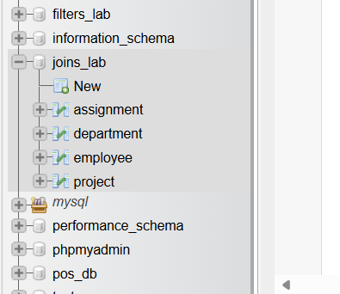
Create a Table :
- Department
- Employee
- Project
- Assignment
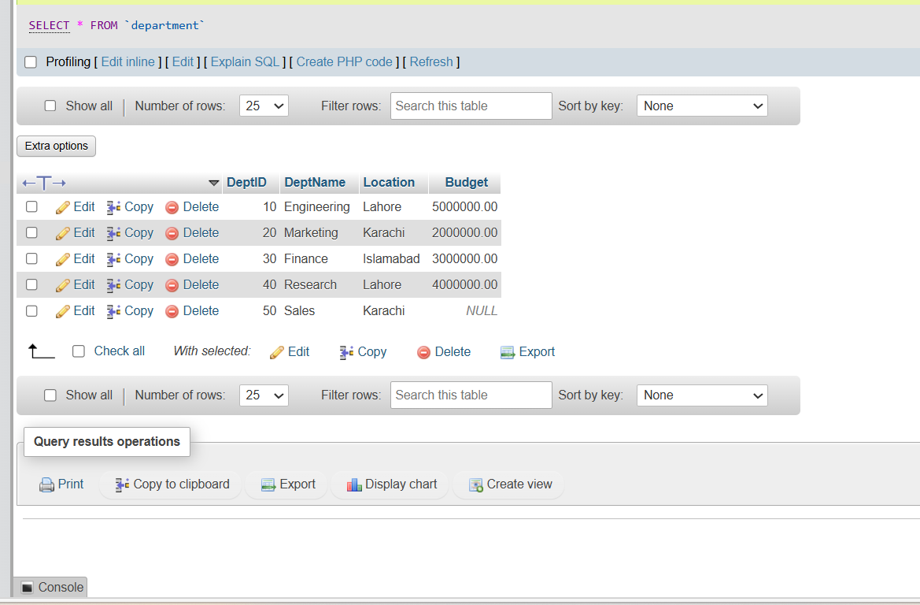

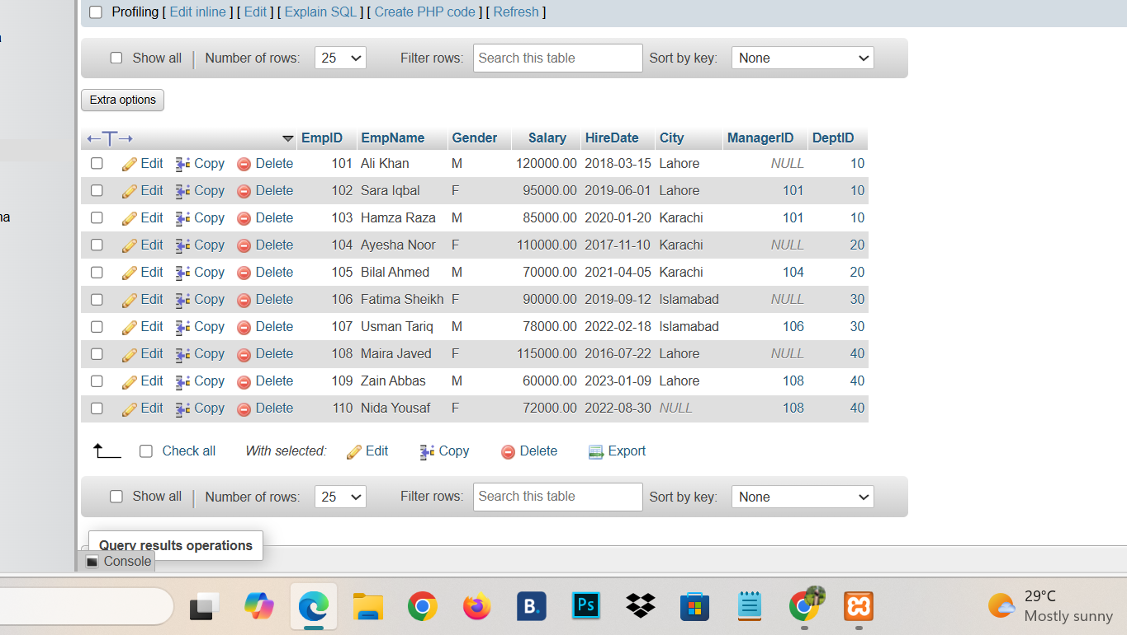

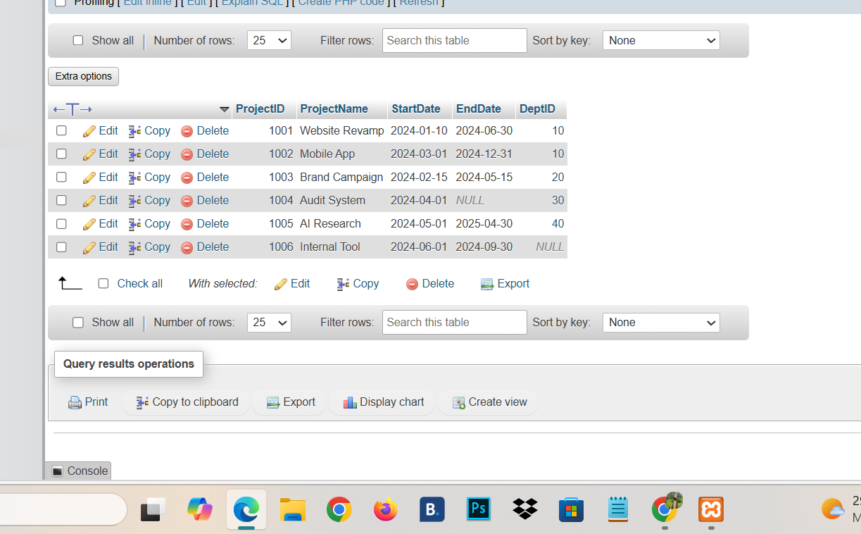

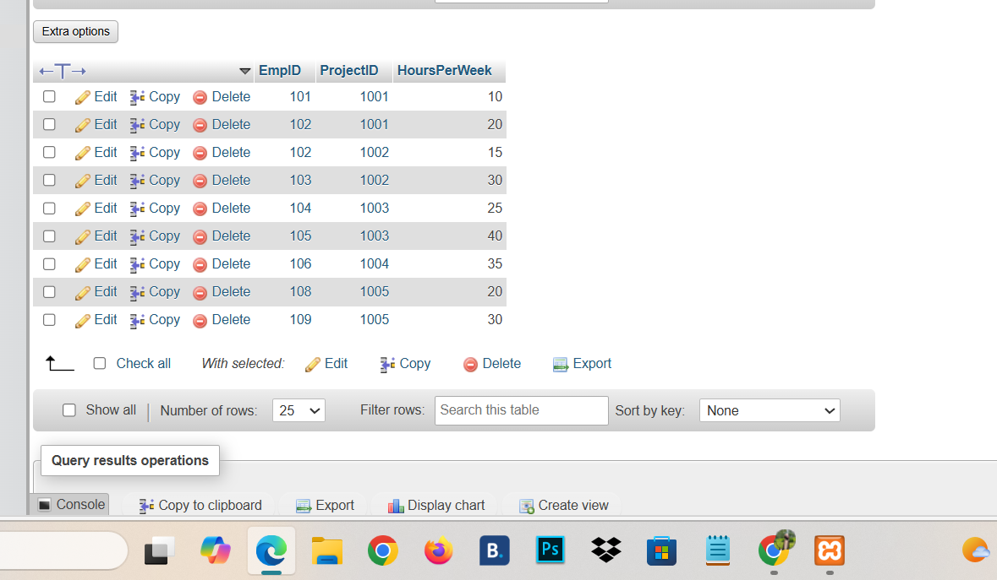
Part A
A1: Every Employee with a Department name and location :
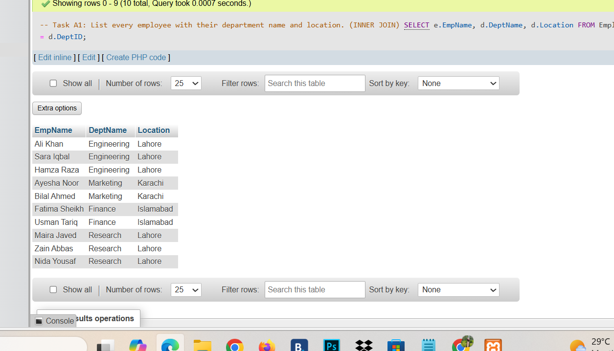
A2: Employee including Null DepID:
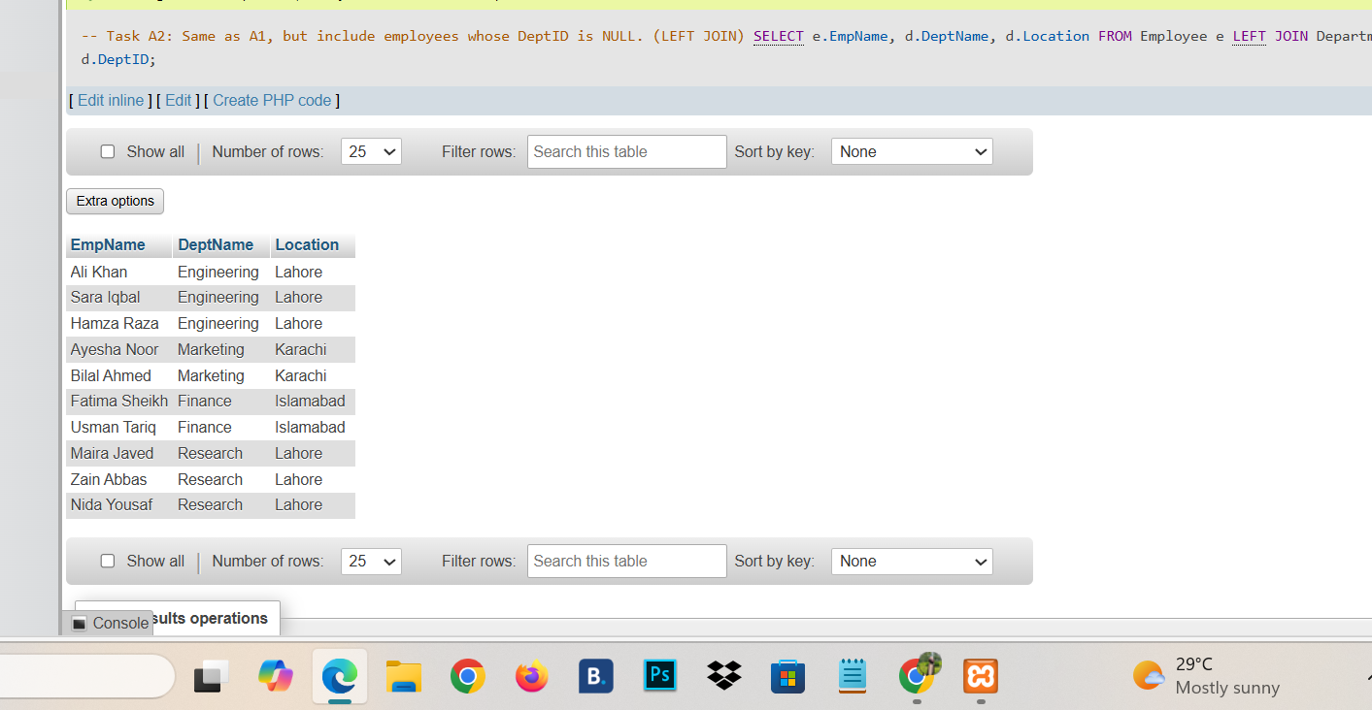

A3: Every Dep with Employee:

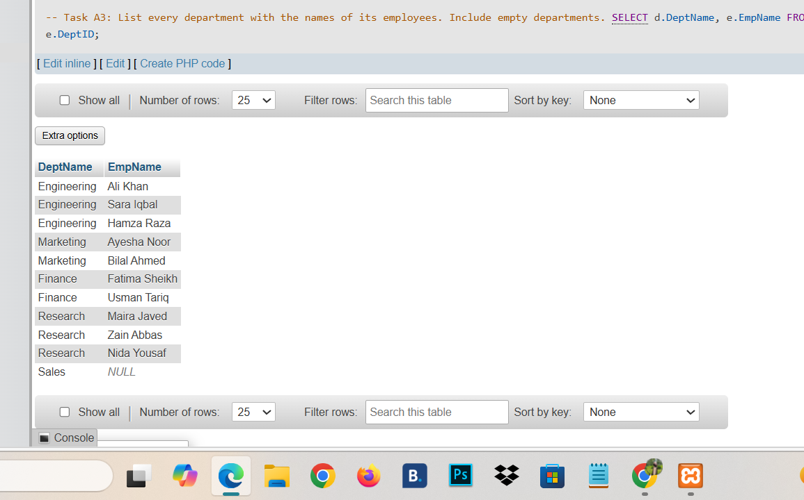
A4:Every Project with Dep:

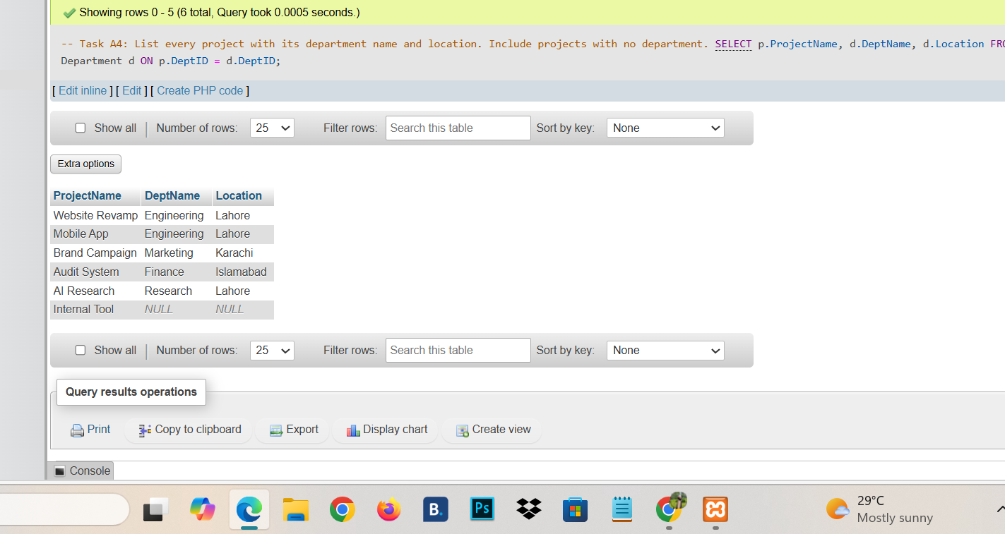
A5: Employee Without Project :
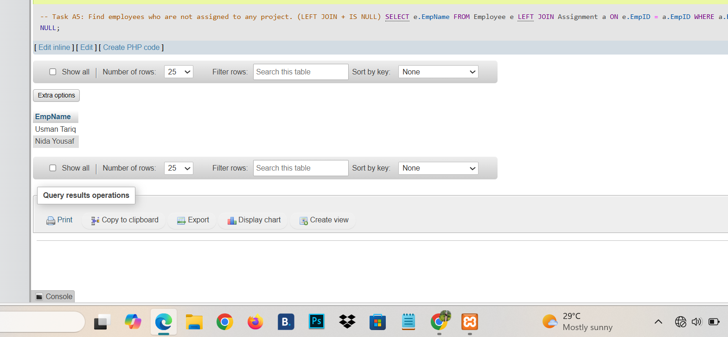
A6: Project with no assignment:
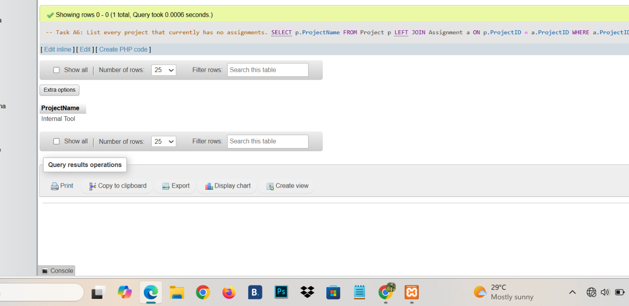

A7: Engineering employee +Salary descending :
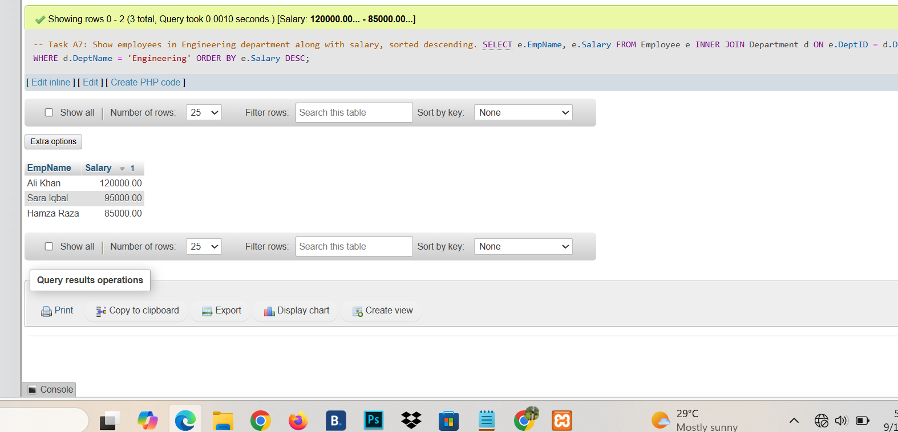
A8: Employee in Lahore Based Dep:

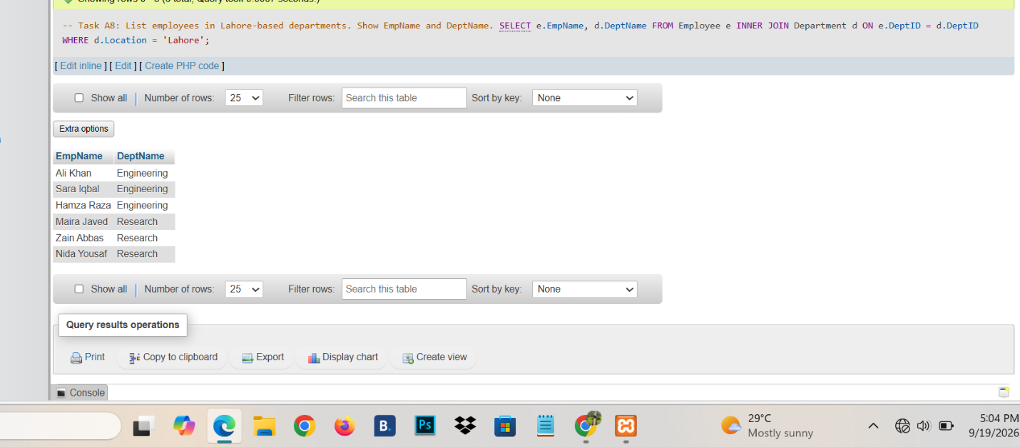
A9: Employee count per dep:

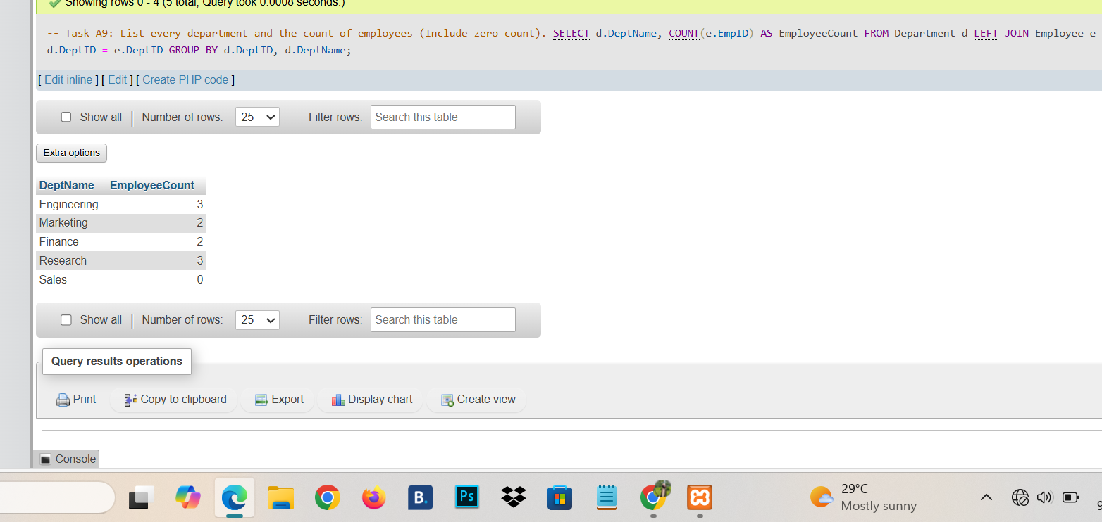
A10: Full outer Join :
